EC-341 Digital System Design
BS (CE)-2021
LAB REPORT # 11

Submitted By:
Reg. No. | Name
21-CE-009 | Huzaifa Shahbaz
21-CE-020 | Muhammad Ibthesam
21-CE-021 | Yawar Ali Malik

Department of Computer Engineering
HITEC University Taxila
 | Presentation  (Format(0.5)+Title (0.5)+  Conclusion(1)+Procedure(2)+Objective(1)) | Calculation/Coding | Observation/ Program Results | Total
Total | 5 | 5 | 5 | 15
Obtained

___________________________
Lab Instructor.
Fasih Ahmad
Experiment #11
Implementation of Mealy State Machine
Objective: 1. State Machine as a Controller 2. Design of Mealy State Machine 3.Overlapping and Non-Overlapping 4. Example 5. Lab Tasks

Equipment/Software Used: Xilinx Vivado

Procedure: A state machine is an abstract way of describing the behavior of a controller. The state machine description reduces the description of any controller to just four things: inputs, outputs, states, and state transition rules. The state machine description contains no details about the implementation of the controller (no flowcharts, programs, schematics, mechanical diagrams, etc.). Instead, a state machine only describes the different states that the controller can be in, the outputs in each state, and what input conditions will cause transitions between states. A state machine description can be used to describe and analyze existing systems and to aid in the design of new systems. The simplified description represented by a state machine allows us to verify proper operation and document the logical operation of a controller before proceeding with detailed design (e.g.writing a program or designing hardware). Design of State Machine: There are four steps to designing a state machine: 1.define the outputs – these are the output signals used by the controller 2.define the inputs – the input signals provided to the controller 3.define all of the possible states that the controller will need to be in and what values the outputs will take for each of these states 4.define the exact input conditions that will cause the state machine to switch from one state to another. Inputs and Outputs: A controller’s inputs are typically signals from sensors such as switches, thermometers, pressure gauges, and so on. The outputs are signals that drive actuators such as motors, valves, displays, etc. We will restrict ourselves to inputs and outputs that are binary values (represented as 0/1, false/true, or low/high). To simplify the state machine description, each input and output is given an abbreviation, usually mnemonic. For example an input that indicates that a tank is full might be given the label full, an output that turns a drill motor on might be given the label drill.

Tasks
Task #1: Execute the code, given in example for overlapping/non-overlapping case. STATE DIAGRAM: 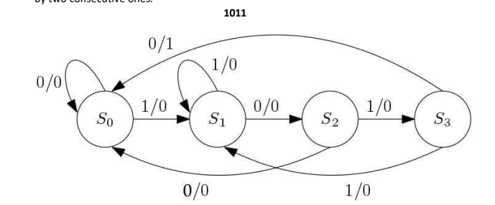
Truth Table:
Present State | Input | Next State | Output
S0 | 1 | S1 | 0
S0 | 0 | S0 | 0
S1 | 1 | S1 | 0
S1 | 0 | S2 | 0
S2 | 1 | S3 | 0
S2 | 0 | S0 | 0
S3 | 1 | S1 | 1
S3 | 0 | S2 | 0

Verliog: module mealy(
input din,
input clk,
input reset,
output reg y
);
reg [1:0] cst, nst;
parameter S0 = 2'b00,
S1 = 2'b01,
S2 = 2'b10,
S3 = 2'b11;
always@(posedge clk)
begin
if (reset)
cst <= S0;
else
cst <= nst;
end
always @(cst or din)
begin
case (cst)
S0: if (din == 1'b1)
begin
nst = S1;
y=1'b0;
end
else
begin
nst = cst;
y=1'b0;
end
S1: if (din == 1'b0)
begin
nst = S2;
y=1'b0;
end
else
begin
y=1'b0;
nst = cst;
end
S2: if (din == 1'b1)
begin
nst = S3;
y=1'b0;
end
else
begin
nst = S0;
y=1'b0;
end
S3: if (din == 1'b0)
begin
nst = S0;
y=1'b1;
end
else
begin
nst = S1;
y=1'b0;
end
default: nst = S0;
endcase
end
endmodule module testbench();
reg sequence_in;
reg clock;
reg reset;
wire detector_out;
mealy uut (.din(sequence_in),.clk(clock),.reset(reset),.y(detector_out));
initial
begin
clock = 0;
forever #5 clock = ~clock;
end
initial
begin
sequence_in = 0;
reset = 1;
#10;
reset = 0;
#10;
sequence_in = 1;
#10;
sequence_in = 0;
#10;
sequence_in = 1;
#30;
sequence_in = 0;
#10;
sequence_in = 1;
#10;
sequence_in = 0;
#10;
sequence_in = 0;
#10;
sequence_in = 1;
#10;
sequence_in = 1;
#10
sequence_in = 0;
#10;
sequence_in = 1;
#10;
sequence_in = 0;
#10;
sequence_in = 1;
#10
sequence_in = 0;
end
endmodule
Waveform: 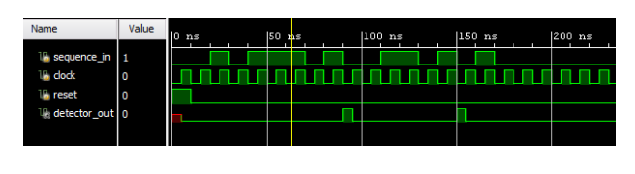

Task #2: You are required to write code for a basic sequential state machine using mealy based design, which detects 11011 for the following cases: a. Overlapping b. Non-Overlapping STATE DIAGRAM: Mealy machine (Non-Overlapping) of 11011 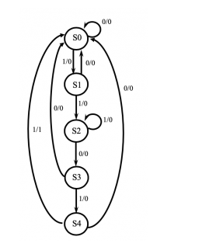 Truth Table:
STATE DIAGRAM: Mealy machine (Overlapping) of 11011 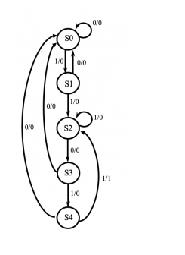 VERLIOG CODE: module sequence_detector(
input clk,
input reset,
input data,
output reg detected
);
parameter IDLE = 2'b00;
parameter STATE1 = 2'b01;
parameter STATE2 = 2'b10;
parameter STATE3 = 2'b11;
reg [1:0] state, next_state;
always @(posedge clk or posedge reset) begin
if (reset)
begin
state <= IDLE;
end
else
begin
state <= next_state;
end
end
always @(*) begin
case(state)
IDLE: begin
if (data)
begin
next_state = STATE1;
end
else
begin
next_state = IDLE;
end
detected = 0;
end
STATE1: begin
if (data) begin
next_state = STATE2;
end else begin
next_state = IDLE;
end
detected = 0;
end
STATE2: begin
if (data) begin
next_state = STATE3;
end else begin
next_state = IDLE;
end
detected = 0;
end
STATE3: begin
if (data) begin
next_state = STATE2;
detected = 0;
end else begin
next_state = STATE1;
detected = 0;
end
if (state == STATE2 && data) begin
detected = 1;
end
end
endcase
end
endmodule
module sequence_detector_tb();
parameter CLK_PERIOD = 10; // Clock period in ns
reg clk;
reg reset;
reg data;
wire detected;
sequence_detector uut (
.clk(clk),
.reset(reset),
.data(data),
.detected(detected)
);
always #((CLK_PERIOD/2)) clk = ~clk;
initial
begin
clk = 0;
reset = 1;
data = 0;
#20; // Wait for 20 ns
reset = 0; // Deassert reset

// Test case 1: Non-overlapping pattern
#10; data = 1;
#10; data = 1;
#10; data = 0;
#10; data = 1;
#10; data = 1;
#10; data = 0;
#10; data = 0;
#10; data = 1;
#10; data = 1;
#10; data = 1;
#10; data = 0;
#10; data = 1;
#10; data = 0;
#10; data = 1;
#10; data = 1;
#10; data = 1;
#10; data = 0;
#10; data = 1;
#10; data = 1;
#10; data = 1;
#10; data = 0;
#10; data = 1;
#10; data = 1;
#10; data = 0;
#10; data = 1;
#100;
$finish;
end
endmodule
Waveform: 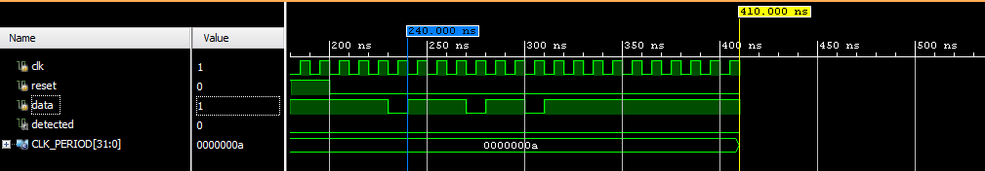

Conclusion: In conclusion, we used a thorough behavioral testbench to validate both overlapping and non-overlapping scenarios after implementing a Mealy state machine for pattern identification in Verilog.

